VENANGO TECHNOLOGY CENTER
JOINT COMMITTEE
1 Vo-Tech Drive
Oil City, Pennsylvania 16301

MINUTES

November 7, 2022

The regular meeting of the Venango Technology Center Joint Committee was held this evening in the Cafeteria of the Venango Technology Center, 1 Vo-Tech Drive, Oil City, PA 16301. Mr. Carson called the meeting to order at seven o’clock (7:00) p.m.

Mr. Carson asked the members to pause for a moment of silence.

Mr. Carson asked the members to stand for the pledge of allegiance.

Roll Call: Present: Ben Carbaugh, Troy Johnston, Shari Neely, Lynn Cressman (zoom), Andy Boland,
Don Judy (zoom), Todd Carson

Absent: Mark Marterella, Stephen Kelley, Jeff Thomas

Also Present: Mr. Mario Fontanazza, Mr. Kevin Briggs (zoom)

Mr. Carson stated the Joint Committee members had received copies of the Minutes of the October 3, 2022 meeting in the mail. He asked if there were any additions, corrections or deletions.

Mrs. Neely, seconded by Mr. Carbaugh, moved to approve the Minutes of the October 3, 2022 meeting as submitted.

Roll Call: Ayes: Ben Carbaugh, Troy Johnston, Shari Neely, Lynn Cressman, Andy Boland,
Don Judy, Todd Carson

Nayes: None, motion carried.

The Treasurer and Secretary’s Report and the Special Account report for 11/7/2022 were submitted for information.

Mrs. Neely, seconded by Mr. Carbaugh, moved to accept the Treasurer and Secretary’s Report and the Special Account report for 11/7/2022 were approved as is.

The motion was unanimously approved.

A list of bills from 10/4/22 – 11/7 /22 in the amount of $875,421.06 were presented for approval.

Mrs.Neely, seconded by Mr. Carbaugh, moved to approve the list of bills as presented.

Roll Call: Ayes: Ben Carbaugh, Troy Johnston, Shari Neely, Lynn Cressman, Andy Boland,
Don Judy, Todd Carson

Nayes: None, motion carried.

Under Communications, Mr. Fontanazza discussed the Professional Advisory Committee. He also discussed the Calendar of Events for the month of October and the Monthly Enrollment Report as of 11/7/22 were submitted.

Mr. Carson requested approval of the action items as presented. Item 8. a) i.- vi. in one motion.

Mrs. Neely, seconded by Mr. Carbaugh, moved to approve action items i.- vi. in one motion as follows:

- Approve additions to the Occupational Advisory Committees.
- Approve equipment for disposal.
- Approve resignation letter for Eric Decker Practical Nursing instructor effective November 30, 2022 or any mutual time agreed to prior.
- Approve moving Kelly Weaver from Part-time Practical Nursing instructor to Full- time effective upon Eric Decker’s resignation.
- Approve advertising for a Part-time Practical Nursing instructor.
- Approve the Chief School Administrator stipend at $5,000.00 annually per term.

Roll Call: Ayes: Ben Carbaugh, Troy Johnston, Shari Neely, Lynn Cressman, Andy Boland,
Don Judy, Todd Carson

Nayes: None, motion carried.

Mr. Adams discussed the Joint Committee Membership report.

Mr. Adams stated that Mr. Bill Vonada would take over as Chief School Administrator at the reorganization
meeting in December 2022.

Mr. Fontanazza reviewed his Issues/Activities for October 2022.

Mr. Carson asked if there was any old business.

None was noted.

Mr. Carson asked if there was any new business.

None was noted.

Mr. Carson mentioned that a Rocky Grove past student, Duncan Hickey, was on Coop and is now a success story working full-time at Montgomery Truss.

Upon motion by Mr. Johnston, seconded by Mrs. Neely, the meeting adjourned at fifteen minutes past seven (7:15) p.m.

Recorded by
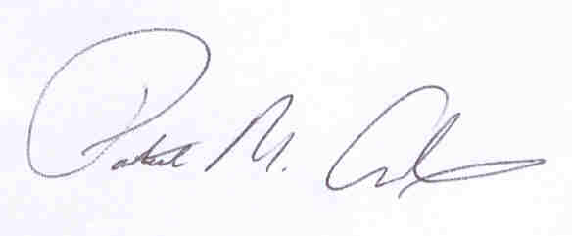
Patrick M. Adams
Secretary, Joint Committee

